Softball Fans:
How to Set Parental Expectations
Managing the expectations of your team's biggest softball fans, the parents, is one of many challenges of coaching youth softball.
If not properly handled, this issue can become quite thorny, be it an issue around playing time, position in the batting order, position on the field, practice attendance, abusive behavior by parent or player, or whatever, this issue needs to be addressed early in the team's formation. If this issue is allowed to run unchecked, any chance of establishing your coaching psychology, will evaporate quickly. Team harmony is key in establishing your ability to effectively run the team. At the end of the day, the parents are interested in making sure that their daughters are being treated fairly, are being given an equal opportunity to play and advance their skills and that you are happy that their daughter is on your team. They really are your team's biggest softball fans. Sometimes, however, the actual interpretation of what you are doing, without a clear set of guidelines can lead to a serious break down in communication and a very big problem for you.
One of the more effective means to achieve this team harmony is by utilizing the team letter. (See below) This has been generally used in a travel team environment, where the goal is to keep the team together year after year as you build on your previous successes while integrating new players in seamlessly. It may also have some application at the recreation team level, where a communication of practice time, equal playing time, and your general philosophy around coaching explained upfront may help parents understand why you are doing the things you are.
If you are coaching in a recreational league that requires everyone to play equally in the infield and outfield, the letter should state that. If you have practice time at a certain time and you expect parents to be there to pick up their daughters at a certain time, the letter should state that. Basically, the letter is essential in establishing a baseline understanding by the parents of why you are doing what you are doing.
In addition, player and parent conduct expectations are also set. I have also seen where the "24 hour" rule has been defined and enacted. The 24 hour rule is where a parent sees something happen during the game impacting the treatment of their daughter and is extremely unhappy with how things were handled. The 24 hour rule state that issues of this type should only be addressed to the coach 24 hours after the end of the tournament. The benefit of the 24 hour rule is that typically by the time 24 hours has passed, most of the emotion of the situation has dissipated and both parties (parents AND coach) can then discuss the situation as adults.
Again, the object with these tools is to ensure team harmony as you deal with the ups and downs of the season, be it from the players, or from their biggest softball fans, the parents.

Sample letter:

Dear Team Members and Parents,
Welcome to the 20XX-20XX Team Name Softball Team. We are pleased that you have chosen to join us and play this year’s team. The other coaches and I are looking forward to another successful season.
Softball can be a very rewarding experience. It is our hope that the upcoming year will offer you a chance to make new friendships and develop your skills on the field. We have three goals for the team, they are:
1. Become a better softball player and a better person
2. Put a representative team on the field
3. Have a good time; enjoy yourself and your teammates.

We will do our best to help you achieve these goals. Because success does not come easily, we will be asking you to commit your time and effort so that these goals may be realized.

Do not hesitate to contact Coach NAME or me with any questions you may have.
Once again, welcome to TEAM NAME.
Coach

How to Play Softball:
The Coach’s Role

Often times, when finding information on how to play softball, the primary focus is on the advancements of skills of the players. Not often do you see resources attempting to help advance the skills of the coach. It's not too often you find a good team and a poor coach. Usually a team is good because the coach is good. So how do you achieve that level of competency? Particularly when you are new to softball? Especially if you never played fastpitch softball?
Let me be clear right upfront for all of the dads out there. Just because you played baseball growing up does not mean you can teach your team how to play softball. You have some of the basics, like the number of players on the field, you have to pitch, you have to hit, and you have to field, but the execution of these skills are in many cases quite different.
Coaching youth softball brings an awesome responsibility. You may be the first person to be teaching the young lady outside of what her parents may have shown her. How do you balance time between your top and lesser players? How do you teach a love of the game, so they want to come back again and again and can't wait to get to the field be it for a game or practice (especially practice)? How do you keep everyone engaged during the entire practice, balancing the too simple with the too complex? At what levels do you introduce different concepts of the game?
Dealing with teaching the players how to play softball is one thing, but how do you handle your biggest softball fans, the parents? Mishandle, and this will be your undoing. And you will get both ends of the spectrum, from the most engaged parent who believes their daughter will be an Olympic Champion to the parent who looks at your team as nothing more than a babysitting service. Learn how to set expectations with the parents and how to handle these delicate situations.

So, how do you start making it a reality? How do you balance time between your top and lesser players? How do you teach a love of the game, so they want to come back again and again and can't wait to get to the field be it for a game or practice (especially practice)? How do you keep everyone engaged during the entire practice, balancing the too simple with the too complex? At what levels do you introduce different concepts of the game?
So let's start with practice set up. Remember that when coaching youth softball, you want to maximize the two hours to permit as many players as possible to be working on particular skills to increase their abilities. Coaching youth softball also means keeping it fun and interesting. But how do you do this with anywhere from 12 – 20 players? The best way to do this is by creating a station practice.
A station practice is where you divide the team into smaller groups and set aside a spot (or station) on the field to work on a particular set of fastpitch softball drills. Note that there are multiple skills across the game of fastpitch softball being worked on.
Some things to note about the station practice.Tthe team is broken down into groups of two. If there are an odd number of players, then a coach will team up with one of the players. The station practice is actually a practice of multiple stations. The groups of two rotate to the substation during the duration of that station practice Each substation lasts five minutes and then the groups move to the next substation. When all of the groups complete all of the drills, the 30 minutes should have elapsed, and the groups then move onto the fielding/running drills, and the process begins again.
Note the timing of the entire practice: 2 hours. Now you have your players working the entire two hours with no standing around. In addition, time can be adjusted for those things you believe your team needs to focus on.
A final note on the station practice: As part of coaching youth softball, the softball tactics section was where you brought the team back together to do one of two things; either talk to the team about the fundamentals of the game of fastpitch softball, like reviewing signs, or the like or play a game. There is nothing like competition to get the blood flowing. So try, if you can, to put some sort of team game in every practice where the girls get to compete against each other.
Drills should be rotated through the program so that no two practices look exactly alike. Keeping it fresh will hold the interest of your players. Drills should also be targeted at the skill level of your players, so 10 & Under and younger should focus on basic swing, throwing, and fielding techniques. As the team gets older and skills are introduced, like base stealing, bunting (if not already part of the game), and so forth, these skills should find a place in your program. For pitchers and catchers take them to the side or split out a part of the practice that is targeted at them.

Station drills:
Station 1: Hitting from the tee. Each player takes 5 swings from the tee hitting into net. We have parent volunteer observing the player’s hitting techniques. Players rotate after 5 swings. After 5 minutes group 1 goes to station 3 and is replaced by group 2.
Station 2: Soft toss hitting. Each player takes 5 swings into net. We have parent volunteer toss (angled from side & behind) with mix of tosses (inside toss = pull ; middle toss = up the middle ; outside toss = opposite field). Players rotate after 5 swings. After 5 minutes, to to station 4.
Station 3: Coach pitch. Each player takes 5 swings from home plate at normal pitching distance. We have 2nd coach pitch and observe the swing for any needed instruction learned at station 1 and developed through stations 2 and 3. Players rotate after 5 swings. (we have the 1st group players that have already hit “retrieve” their balls).
Name of Drill: Hitting Tee
Who: Entire Team
Duration: Rotation through the team
Explanation: This is the baseline drill, usually in two person groups. You will need a tee, either softballs or wiffle balls, the hitting net, and the player's bat. As one works on her swing, hitting the ball into the net, her teammate places the ball on the tee. The tee should be placed on various locations on home plate to work taking the ball to right field for an outside pitch; taking the ball to left field for an inside pitch; and so forth. In addition, the tee height should be raised and lowered to work on pitches not only inside and outside, but also up and down in the strike zone. The key is that a good swing must be repeatedly made with line drives into the net resulting.
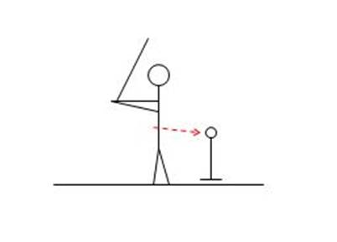
Worked on: Perfecting her swing on pitches in various parts of the strike zone.

Name of Drill:Double Tee
Who:Entire Team
Duration: Rotation through the team
Explanation: In this softball hitting tip, the team can be broken down into pairs. You will need two tees, either softballs or wiffle balls, the hitting net, and the player's bat. The object of this drill is to eliminate the loop in your player's swing. As taught with the rotational swing, the hitter should bring her hands directly to the ball, without dropping them down. Line up two hitting tee front to back. The back tee should be a little lower than the front tee. Place a ball on the front tee. The player then hits the ball off of the front tee. If she hits the back tee, she is looping her swing. Make corrections in her mechanics, and repeat the process.
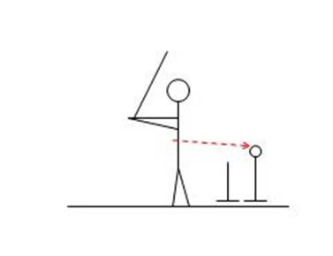
Worked on: Swing that produces hands to the ball without a loop in the swing.

Name of Drill:Three Ball Call Out
Who:Entire Team
Duration: Rotation through the team
Explanation: The team can be broken down into pairs. You will need different color wiffle balls, the hitting net, and the player's bat. This is a form of soft toss, which is explained on the Fastpitch Softball Hitting Drills page. You can start with two different colored wiffle balls first and work up to three. See the ball clearly and keeping your eye on the ball is one of the keys to successful hitting. In this drill, the soft tosser will throw multiple balls (two at first and then three), and call out the color of the ball for instance "red") to hit. The batter will then attempt to hit that color ball into the net. Go through several rotations then have the girls switch spots.
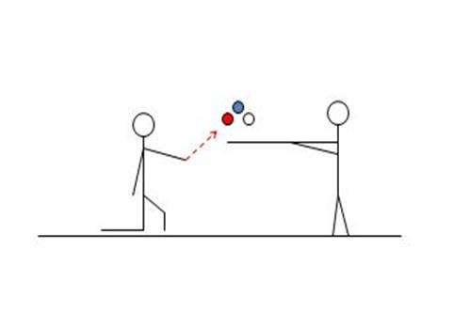
Worked on: Pitch identification and focus on the ball.

Name of Drill:Hip Swing
Who:Entire Team
Duration: Rotation through the team
Explanation: Split the team into pairs. You will need softballs or wiffle balls, a tee, the player's broom stick or bat, and the hitting net. Have the hitter position the bat or broom stick horizontally behind her back. Place the ball on the tee. The batter must turn her hips with the bat or broom stick following the hips to hit the ball off the tee. The key to a solid hit is utilizing the entire body, particularly the hips in the swing. This drill trains the player to bring her hips through with her swing.
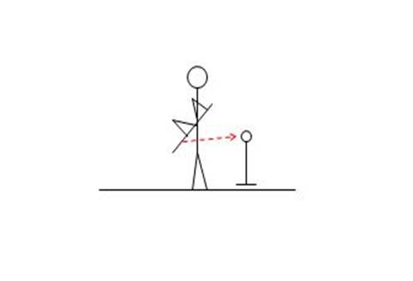
Worked on: Proper mechanics in the use of the player's hips as part of her swing.

Fastpitch Softball Drills:
Practice Setup & Team Drills
Good practice set-up and selection of the appropriate fastpitch softball drills will enable your team to achieve its optimal playing capability.
You generally have about two hours per session for practice, so make sure you are using all of that time!
Another one of my favorite quotes says it even better:
Practice doesn’t make perfect.
Perfect Practice makes perfect
Before every practice and game, it is important that your players stretch properly. Players who have not properly stretched are far more susceptible to injuries. As a matter of fact,this should be the first thing the players do before picking up a bat or softball. Make it dynamic so the players enjoy doing it and avoid those needless injuries.
Your fastpitch softball drills should also simulate game situations with no base runners and some basic bunt defenses or how to handle the situation with baserunners. Additional bunt coverage formations are covered on the bunt defense page. If you drill this during practice, your players will react to plays rather than stop and think about what they are doing. Reacting versus thinking will provide your team that split second advantage to get the needed out.
Infield and outfield fastpitch softball drills are standard in any practice schedule. Make sure you have a selection of different drills that you rotate through so that you keep your player’s interest. You may be working on a single skill, but you should have different drills that achieve that goal for you.
Softball throwing drills, focused on both accuracy and strength of throw, as well as , as specific outfield throwing drills should be worked into your program. A good versus poor throw could determine the outcome of the game.
And let’s not forget base running drills, including take off from the base, proper touching of the bases, picking up the coaches which generally separates the good from the very good teams. This is also another means to build conditioning into your practice schedule while teaching a particular fastpitch softball skill.

Softball Practice Drills:
Getting Your Players into Position
Every pitch in a softball game represents a different game situation. These softball practice drills will teach your players where to be in different basic game situations.
Part of every practice should be dedicated to teaching your team where you expect player to be in a given situation. As you progress through games and you notice players seemingly confused, write down the situation and develop softball practice drills to address that situation during your next practice. Every player should be moving on every play. You want to make sure they are moving where you want them to move and that they do not have to think but simply react.
Here are six basic game situations that you can use as softball practice drills. Notice that every base is covered on every play. As you add base runners into the situation, it is a matter of teaching your players where you want them to throw the ball to get the out.

Situation 1: Ground Ball to Shortstop
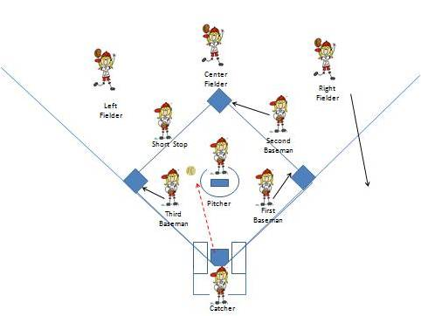
When the ball is hit, the first baseman covers first base. Realizing she cannot reach the ball, the third baseman covers third. The second baseman covers second base. Your right fielder must react and back up first base should there be an errant throw. The center and left fielder move to back up short stop should the ball get through.

Situation 2: Ground Ball to Second Base
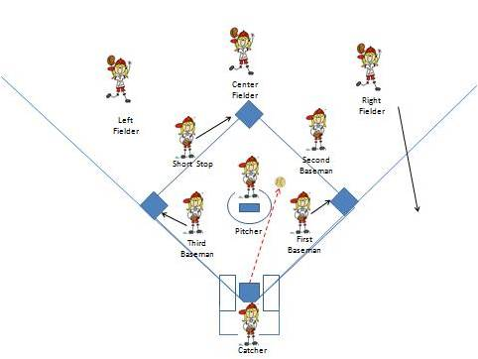
When the ball is hit, and the first baseman realizes she cannot field the ball, she covers first base. The third baseman covers third. The shortstop covers second base. Your right fielder must react and first determine if the ball will get through, if not she must back up first base should there be an errant throw. The center fielder moves toward the ball in case it gets past the second baseman and left fielder move to back up second should there be an error at first and there is a play at second.

Situation 3: Hit to Leftfield/Centerfield
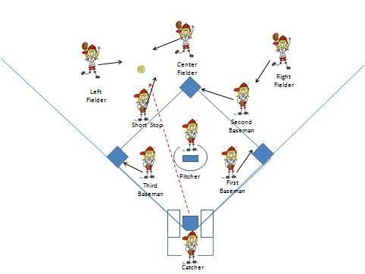
When the ball is hit, the first baseman covers first base. The third baseman covers third. The second baseman covers second base. The shortstop moves out to short leftfield to be the cut off. Your second baseman aligns her between the outfielder fielding the ball and the second base bag by shouting left or right. Your right fielder lines herself up to back up a throw to second in short right field. The center and left fielder move to field the ball communicating who has it.

Situation 4: Hit to Right Field
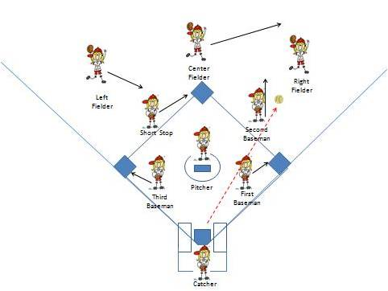
When the ball is hit, and the first baseman covers first base. The third baseman covers third. The shortstop covers second base. The second baseman is the cutoff moving to short right field. Your shortstop aligns her between the outfielder fielding the ball and the second base bag by shouting left or right. Your left fielder moves towards shot left field to backup an errant throw to second. The right fielder moves to field the ball while the centerfielder moves to back up the right fielder. Note that the rightfielder may have a play at first base, so the first baseman must cover.

Situation 5: Bunt Play with No Base Runners
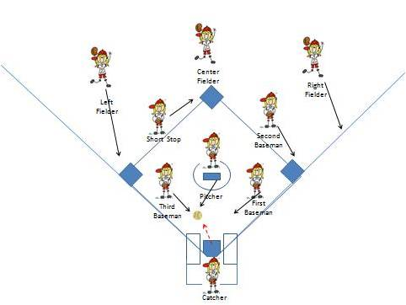
When the ball is bunted, the first baseman, third baseman, catcher and pitcher move to field the ball communicating who has it. Primary is third down the third baseline and first baseman down first baseline unless directly at the pitcher or right in front of the plate where the catcher can get it easily. The second baseman covers first base. The shortstop covers second. The leftfielder covers third. She must get to third in case there is an errant throw. The right fielder moves up the right filed line to back up the throw to first. Centerfielder backs up second.

Situation 6: Bunt Play with Runner at First
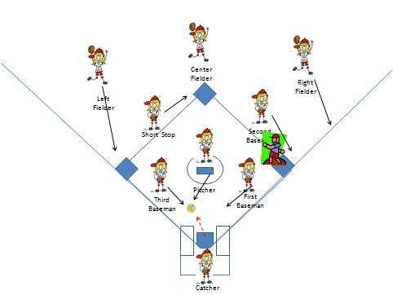
When the ball is bunted, the first baseman, third baseman, catcher and pitcher move to field the ball communicating who has it. Primary is third baseman down the third baseline and first baseman down first baseline unless directly at the pitcher or right in front of the plate where the catcher can get it easily. The second baseman covers first base. The shortstop covers second. The leftfielder covers third. She must get to third so the runner at first does not advance to third because no one is covering third base. The right fielder moves up the right filed line to back up the throw to first. The centerfielder backs up second base should there be a throw to second.

Softball Tips:
Playing Defense with Runners on Base
Softball practice drills addressed basic defensive alignment. Here are softball tips on handling situations with runners on base.

The good news is if you deployed the basic defensive strategy of covering every base from Softball Practice Drills, it is now a matter of convincing your players to throw to the base that will get the lead runner out. Here is one of our first softball tips. A word of caution: With some younger teams, you may want to continue to deploy the idea of getting the easiest out, based on the arm strength of your infielders. So, for instance, is your second baseman ready to throw to third to get a force out? Of all the softball tips you get, the most important is that you set your team up to always get at least one out, regardless of how unspectacular it may seem.
Here are seven game situations with runners on base and our softball tips on how to handle them. Notice that every base is covered on every play. It is now a matter of teaching your team where they should throw the ball to get the out. Hopefully these softball tips help you decide how you want to play the situation.

Situation 1: Ground Ball to Shortstop with a Runner on First Base
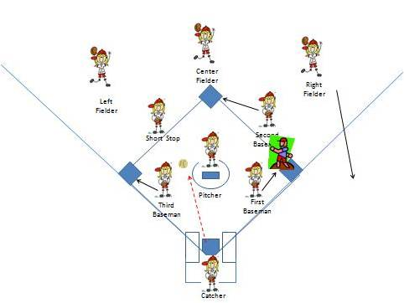
When the ball is hit, the first baseman covers first base. Realizing she cannot reach the ball, the third baseman covers third. The second baseman covers second base and anticipates a throw from the shortstop for a force play at second. Your right fielder must react and back up first base should there be an errant throw. The center and left fielder move to back up shortstop should the ball get through. The shortstop, once she handles the ball, now decides to either touch second base (and throw to first for a possible double play), flip to the second baseman covering second based, or, if the runner at first got a good jump, throws to first for the out. The most important thing is to get an out. For the older teams, it is important to teach the second baseman how to protect herself at second on the toss, pivot and throw to first for a possible double play.

Situation 2: Ground Ball to Second Base with a Runner on First Base
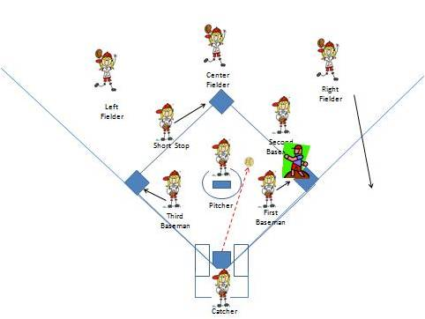
When the ball is hit, and the first baseman realizes she cannot field the ball, she covers first base. The third baseman covers third. The shortstop covers second base anticipating a throw from the second baseman for the force out. Your right fielder must react and first determine if the ball will get through, if not she must back up first base should there be an errant throw. The center fielder moves toward the ball in case it gets past the second baseman and left fielder move to back up second should there be an error at first and there is a play at second. The second baseman, once she handles the ball, now decides to either touch second base (and throw to first for a possible double play), flip to the shortstop covering second based, tag the runner from first as she runs past (and throw to first for the double play) or, if the runner at first got a good jump, throws to first for the out. The most important thing is to get an out. For the older teams, it is important to teach the shortstop how to protect herself at second on the toss, pivot and throw to first for a possible double play.
Situation 3: Hit to Leftfield/Centerfield with a Runner on First Base
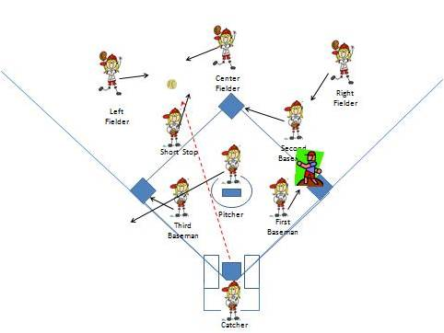
When the ball is hit, the first baseman covers first base. The third baseman covers third. The second baseman covers second base. The shortstop moves out to short leftfield to be the cut off. Your second baseman aligns her between the outfielder fielding the ball and the second base bag by shouting left or right. Your right fielder lines herself up to back up a throw to second in short right field. The center and left fielder move to field the ball communicating who has it. Whether the leftfielder or centerfielder fields the ball, they should then try and get the ball into second base as quickly as possible to get a possible force out a second.

Situation 4: Hit to Right Field with a Runner on First Base
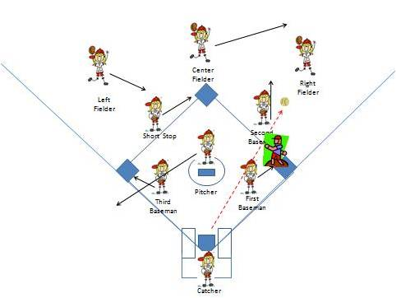
When the ball is hit, the first baseman covers first base. The third baseman covers third. The shortstop covers second base. The second baseman is the cutoff moving to short right field. Your shortstop aligns her between the outfielder fielding the ball and the second base bag by shouting left or right. Your left fielder moves towards shot left field to backup an errant throw to second. The right fielder moves to field the ball while the centerfielder moves to back up the right fielder. When the right fielder fields the ball, she should throw the ball to either second or first to attempt to get a force out. As a general rule of thumb we used is what direction was her momentum taking her? If it was towards second, then throw to second. If it was towards first then throw to first.
Situation 5: Hit to Leftfield/Centerfield with Runners on First and Second Base
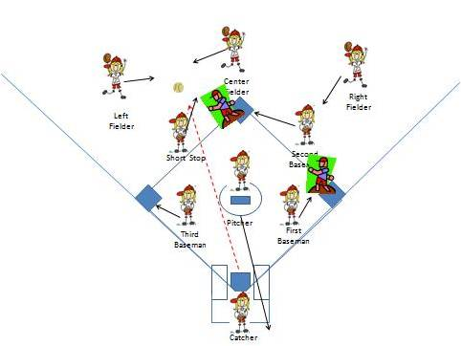
When the ball is hit, the first baseman covers first base. The third baseman covers third. The second baseman covers second base. The shortstop moves out to short leftfield to be the cut off. Your second baseman aligns her between the outfielder fielding the ball and the second base bag by shouting left or right. Your right fielder lines herself up to back up a throw to second in short right field. The center and left fielder move to field the ball communicating who has it. Whether the leftfielder or centerfielder fields the ball, they should then try and get the ball into second base or third base as quickly as possible to get a possible force out. The general rule of thumb we used to determine which base to throw to is what direction was her momentum taking her? If towards third, throw to third. If towards second, throw to second.

Situation 6: Hit to Right Field with Runners on First and Second Base
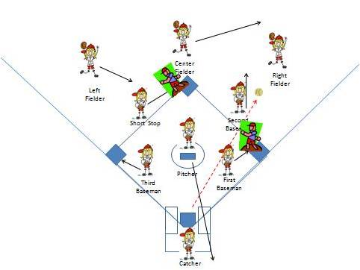
When the ball is hit, the first baseman covers first base. The third baseman covers third. The shortstop covers second base. The second baseman is the cutoff moving to short right field. Your shortstop aligns her between the outfielder fielding the ball and the second base bag by shouting left or right. Your left fielder moves towards shot left field to backup an errant throw to second. The right fielder moves to field the ball while the centerfielder moves to back up the right fielder. When the right fielder fields the ball, she should throw the ball to either second or first to attempt to get a force out. As a general rule of thumb we used is what direction was her momentum taking her? If it was towards second, then throw to second. If it was towards first then throw to first. The shortstop or first baseman, depending on where the ball was thrown, must immediately wheel around to see what the runner on second is doing. If attempting to score, the throw must come to the plate. If stopped at third, the ball must go back into the pitcher’s circle to the pitcher to end the play.
Situation 7: Ground Ball to Second with Bases Loaded and Less Than Two Outs
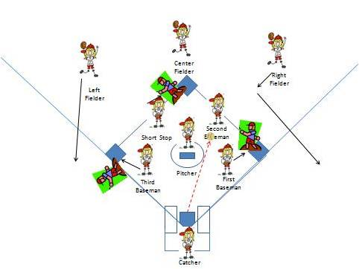
Your infield should be playing in, meaning in front of the base paths. You want to get the force out at home plate (catcher only has to step on home plate before the runner touches it). When the ball is hit, and the first baseman realizes she cannot field the ball, she covers first base. The third baseman covers third. The shortstop covers second base. Your right fielder must react and first determine if the ball will get through, if not she must back up first base should there be an errant throw. The center fielder moves toward the ball in case it gets past the second baseman and left fielder move to back up second should there be an error at first and there is a play at second. The second baseman, once she handles the ball, will throw the ball to home plate, where the catcher, positioned like a first baseman, catches the ball while touching the plate for the force out. If she does not field the ball cleanly the second baseman should look to try and get one out, most likely at first. You want to get at least one out in the situation. Some may even try and play this into a double play, should there already be an out, so as to get out of the inning.

Bunt Defense:
Counteracting Small Ball
When the other team turns to small ball, bunt defense is your most effective way to counteract them. We provided two examples of basic bunt defense on the softball practice drills page. In that case, we introduced the idea of the leftfielder covering third base while your third baseman is charging the bunt. On this page, we will provide a few other ways to play the bunt.
The success or failure of your bunt coverage will rest on the shoulders of your catcher. The catcher is the only player on your team who has a clear view of how the play is developing. She should be the person who calls out which of the charging players should field the ball (including herself) and what base the ball should be thrown to. The ideal play will result in the lead runner being forced out; a good play is getting an out somewhere. I can’t think of a bad out (except maybe a catch in foul territory for either the first or second out that results in the winning run scoring), so always stress to your team to get at least one out.
The first example of bunt defense provides an example of the rotation play. In this bunt defense, the third baseman actually covers third and it is the responsibility of the pitcher, catcher or first baseman to get the bunt up the third baseline. You need an athletic pitcher who has very good reaction time to the ball to do this play successfully on a consistent basis. You also want you third baseman to really sell the idea that she is charging to coax the batter to bunt up the first baseline.
Note that in the last three examples of bunt defense, the second baseman is playing up instead of the first baseman. This bunt defense is deployed when your first baseman and pitcher may not have great reaction time to the bunt. The second baseman, traditionally quicker, steps up and covers the first baseline. This is to discourage the other team from bunting and slapping by moving another quick infielder up on the bunt defense. The first baseman plays more toward the second base hole.
Situation 1: Rotation Bunt Defense with Runners on First and Second
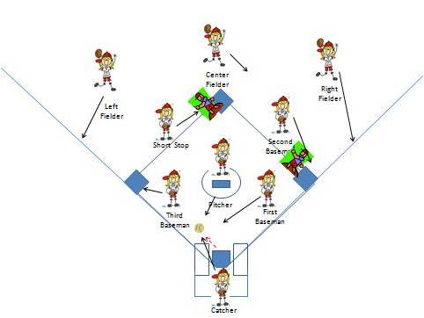
When the ball is bunted, the first baseman, catcher and pitcher move to field the ball with the catcher communicating who has it. Primary is the pitcher or catcher down the third baseline and first baseman down first baseline. The second baseman covers first base. The shortstop covers second. The third baseman covers third after acting like she is charging. The leftfielder backs up the throw to third. The right fielder backs up the throw to first. Centerfielder backs up second. The catcher calls out what base the ball is to be thrown to. The best play is to get the force out at third. The right play is to get an out somewhere.
Situation 2: Bunt Defense with Second Baseman Playing Up with No Runners
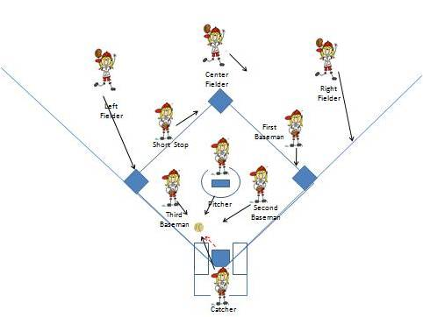
Change to this defensive alignment if the pitcher and first baseman have struggled to cover the bunt up the first baseline. When the ball is bunted, the second baseman, third baseman, catcher and pitcher move to field the ball with the catcher communicating who has it. Primary is third baseman down the third baseline and second baseman down first baseline unless directly at the pitcher or right in front of the plate where the catcher can get it easily. The first baseman covers first base. The shortstop covers second. The leftfielder covers third. She must get to third so the runner at first does not advance to third because no one is covering third base. The right fielder moves up the right filed line to back up the throw to first. The centerfielder backs up second base should there be a throw to second. The throw should go to first.
Situation 3: Bunt to Third Baseline with Second Baseman Up & Rotation on with Runners on First and Second
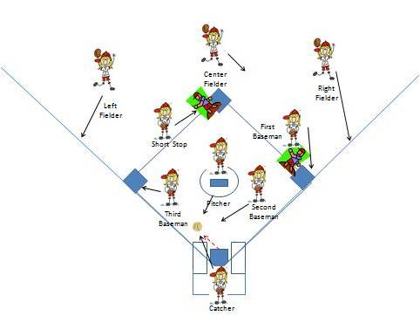
When the ball is bunted, the second baseman, catcher and pitcher move to field the ball with the catcher communicating who has it. Primary is the pitcher down the third baseline and second baseman down first baseline unless right in front of the plate where the catcher can get it easily. The first baseman covers first base. The shortstop covers second. The third baseman covers third. The left fielder backs up the throw to third. The right fielder moves up the right filed line to back up the throw to first. Centerfielder backs up second. The catcher calls out what base the ball is to be thrown to. The best play is to get the force out at third. The right play is to get an out somewhere.

Situation 4: Bunt to First Baseline with Second Baseman Up & Rotation on with Runners on First and Second
When the ball is bunted, the second baseman, catcher and pitcher move to field the ball with the catcher communicating who has it. Primary is the pitcher down the third baseline and second baseman down first baseline unless right in front of the plate where the catcher can get it easily. The first baseman covers first base. The shortstop covers second. The third baseman covers third. The left fielder backs up the throw to third. The right fielder moves up the right filed line to back up the throw to first. Centerfielder backs up second. The catcher calls out what base the ball is to be thrown to. The best play is to get the force out at third. The right play is to get an out somewhere.

Infield Drills:
Handling Ground Balls
The handling of ground balls is essential to the success of any team. Infield drills will help the team improve it proficiency in this area. These drills, although labeled as infield drills, can be applicable to the entire team.
There are two kinds of drills for infielders. The first set of drills addresses the handling of the ground ball, getting into a good throwing position, and making a good throw. In addition to the drills on this page, you will find more drills that works on this aspect of the game on the softball throwing drills page.
The second set of infield drills speaks to situational positioning of players during the game. Who covers what base, when, for instance, a team is bunting? We will review some basic strategy on the softball practice drills page.
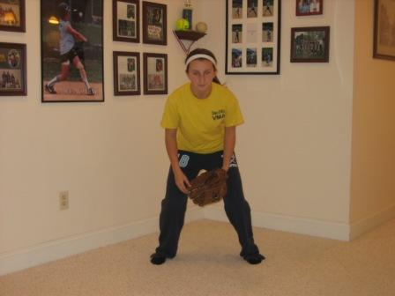
First, let’s talk about the 4 step method of picking up a ground ball. The player is first in the ready position, on her toes ready to charge the ball.
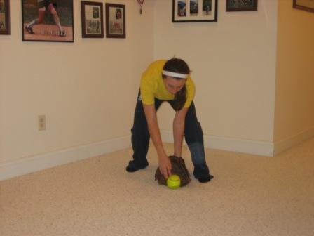
As the ball approaches, the player steps forward with her glove side foot as she picks up the ball with her glove.
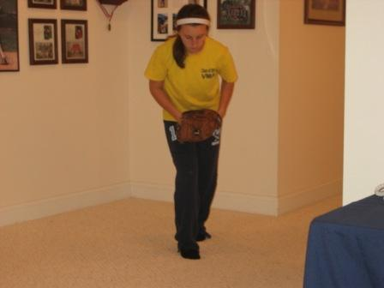
As the player brings the ball up to her midsection, she steps with the throwing hand foot.
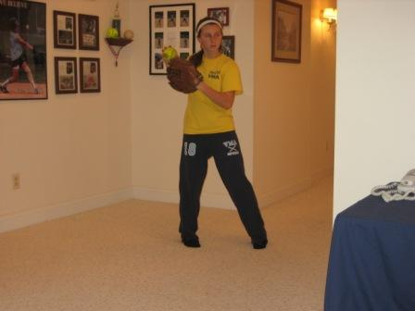
The player then turns her hips and "points" toward the base she is about to throw to with her glove side arm, stepping forward with her glove side foot, while raising to throw the ball. She is now in position to throw the ball.
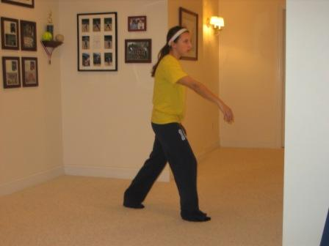
The player then makes a throw to the base by throwing the ball at the same time stepping with her throwing arm foot to put her body into the throw.
This can be turned into a drill by lining your team up in two lines and having one line roll ground balls to the other line as the second line players do the 4 steps. After a few minutes, you then change lines on who is rolling the ground ball.

Fielding and Throwing Drills:
Name of Drill: Dual Lines Ground Ball Drill
Who: Entire Team
Duration: 10 minutes
Explanation: In this infield drill, you split your team into two groups, one group goes to second and the other to short. Pick 2 players to stand beside the two coaches (4 in total) to serve as catcher. The coaches hit a ground ball to the first player in the line (1). The player then throws the ball to the first catcher(2). After the catcher catches the ball and hands it to the coach, she then goes to other line (3). The player who just fielded and threw the ball then goes to back up the second catcher with the coach (4). You continue this rotation as you go several rounds through all of the players, each rotating through both lines. If a player makes a bad throw and the catcher does not catch it, the player takes a lap. If the player catches it, the player goes to be the backup catcher as explained above (of course thanking the catcher for saving her). The idea is to keep this at a fast pace so that all players are constantly moving. The coach can also mix in pop ups during the drill.
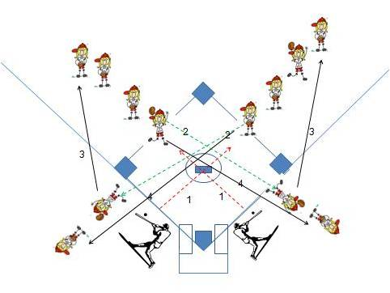

Outfield Drills:
Proper Catching and Throwing Techniques
Outfield drills work on your team's ability to not only catch and throw the ball, but also how to set up and execute relays, where to know to throw the ball given the situation, and where an outfielder should position herself to properly back up a play
Many coaches also use the tried and true outfield drills method of hitting the ball to the outfielders repetitively to teach them how to move back on the ball, how to expect the ball to act, and so forth. For instance, a right fielder should expect a ball to tail towards the foul line if hit by a right handed hitter, since the ball was likely hit off the end of the bat. A similar situation occurs for a leftfielder when they see a left handed hitter.
Below are specific outfield drills to teach certain techniques necessary for your team to be successful. Each will be highlighted below.
Name of Drill: Pop Up Drill
Who: Primarily Outfielders, but good for entire team
Duration: 10 minutes
Explanation: The object of this outfield drill is to teach your players to quickly get into position, find the ball, call for the ball, and make the catch. You will need two players and a coach. The two players lay face down on the ground. The coach stands at the feet of the two players. The coach throws a pop up and yells, "BALL!" This is a signal for the two players to get up on their feet find the ball and the one who spots it first yells, "I got it!", properly position her feet to be ready to make a throw (glove hand foot forward, throwing hand foot back with her shoulder towards the direction of the throw) and makes the catch. Do this repeatedly, rotating the location of the ball. Although a simple drill, the getting up and down is a form of conditioning for the players.
Worked on: Finding a pop up, properly calling for the ball, team work, proper foot work in handling and throwing the ball.
Name of Drill: Indian Run
Who: Entire Team
Duration: 15 minutes
Explanation: The object of this outfield drill is to have your players know how to position themselves to take a relay throw and be able to throw with a minimum of movement. Look at the two pictures.
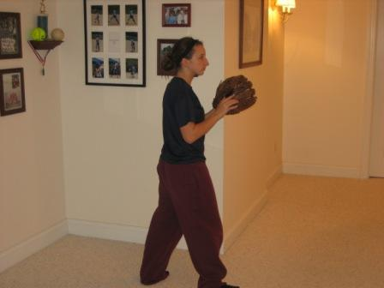
The picture to the right shows the proper stance your player should be in when receiving the ball from her right and throwing to her left (such as a throw from right field to second base). Notice as soon as she catches the ball, she already has her feet set and can throw the ball.
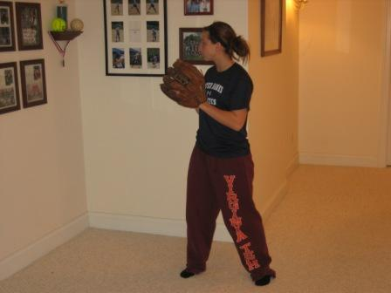
Similarly, the picture to the left shows the proper position when receiving a throw from the left and throwing to the right (such as from left filed to second base). Again, as soon as she catches the ball, she will be ready to throw simply by rotating the top half of her body.
The Indian Run is designed to drill this proper footwork into your players. Divide your team into groups of six. Set up six markers (we typically used balls) in the outfield about 10 years apart. The object is to have each player, in proper position (let’s say the ball is going from right to left, so the players in the middle should look like the first picture above), throw the ball (direction A) to the player next to them and so on down the line. Once it gets to the end of the line, the players in the middle reposition themselves to receive the relay properly (as in the second picture) and the ball is thrown (direction B) to each consecutive player back to the original player at the beginning of the line. When this happens, player 1 (run C) goes to the back of the line, with player 2 (run D)moving to where player 1 was, player 2 to player 1 spot, and so on. If a throw is missed either because it was inaccurate or the player did not catch it, the ball goes back to the player where the errant throw originated and the drill continues.
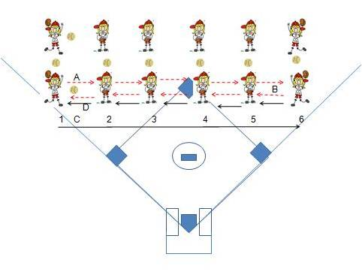
Worked on: Accurate throws, team work, proper foot work in handling and throwing the ball, conditioning.

Name of Drill: Nerf Throw
Who: Entire Team
Duration: 15 minutes
Explanation: The object of this outfield drill is to work on how to track down a ball that is over the players head and make the catch. The basic technique being taught is that when a ball is hit that is over your head, you turn your shoulders in the direction the ball is going and run like you normally would with your glove down, bringing the glove up to catch the ball at the last second. Despite the picture, you do not want your players running with their gloves up in the air. It makes them slower, and it makes for hard hands, meaning the ball is likely to bound out of the glove. We used a nerf football for this drill to change it up. The players should use their gloves for this drill. Split the team in half, with half going to the third baseline and half to the first baseline. A player from the third baseline goes to short and a player from the first baseline goes to second. The coach stands on the pitcher’s mound. The coach throws the nerf for the shortstop first and throws the nerf as a pop up over her head either towards third or second base. The player must turn her shoulders and run and make the catch. After the catch, the next player on the third baseline comes out to short. The coach then does the same thing to the player at second, throwing towards either second or first. After the catch, the next player comes out from the first baseline, and the coach now throws to the player at shortstop and so on.
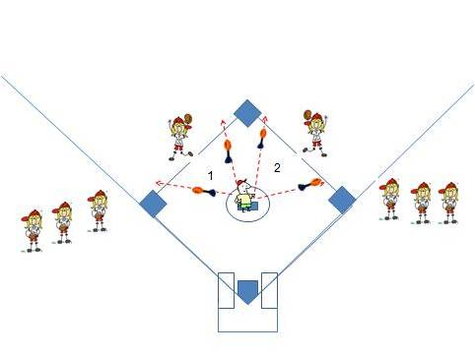

Softball Throwing Drills:
Teaching Strong and Accurate Throws
The objective of softball throwing drills is to help not only the strength of the throw but also the accuracy. Without both, the runners will be safe and your team will only find itself in deeper trouble.
Name of Drill: Third Base Throw
Who: Primarily Infielders
Duration: 10 minutes
Explanation: The objective of this softball throwing drill is to work on foot speed and throwing accuracy. Place three balls randomly between third base and home plate. Put a player on first to catch the throws. Line up the rest of your players at third base. Have a stop watch to time the player. The first player in line lines up behind the third base bag. On "go", the runs to the first ball, and throws it to first, then returns to her original position(1). Without stopping, she repeats the same exercise running to the second (2) and third balls(3) and throwing them to first, each time returning to her original position. After throwing the third ball, when she returns to her original position stop the stop watch. Record her time for future reference. Upon completing the drill, the throwing player then goes to first base and the player on first goes to the back of the line.
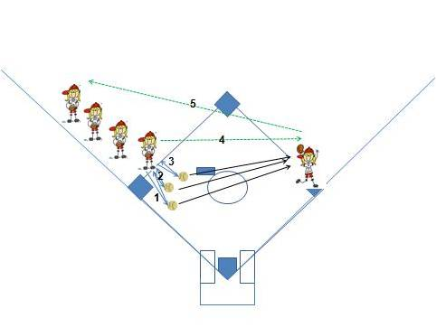
Worked on: Conditioning, accurate throwing, team work, proper foot work in handling and throwing the ball.

Name of Drill: Round the Horn
Who:Primarily Infielders, but for the game, Entire Team
Duration: 20 minutes
Explanation: The objective of this softball throwing drill is to work on throwing accuracy. The drill starts with the coach hitting the ball somewhere in the infield. The infielder fields the ball and throws it to first (1). The first baseman throws it to third (2). The third baseman throws it to home (3).The catcher throws it to the second baseman on second base (4). The second baseman throws it to home where the pitcher catches it (5). The pitcher throws it to second base where the shortstop catches it (6). The shortstop throws it to home where the catcher catches it (7). In order to complete this drill correctly, every player must make an accurate throw.
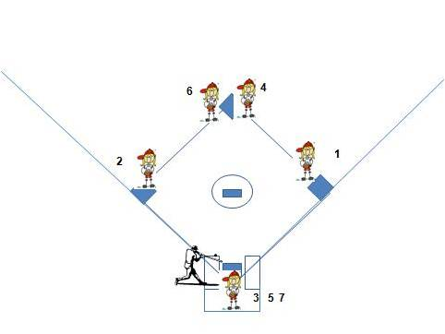
Worked on: Conditioning, accurate throwing, team work, proper foot work in handling and throwing the ball.

Throwing Drills:
Teaching Cutoffs and Accuracy
Outfield throwing drills work on your team's ability to accurately hit the cut off. In addition, you also want to work on throwing accuracy from the outfield to home plate. You never know when you might need a game saving throw form an outfielder.
When working on the throwing drills listed below, make sure you have your player in the cut off position properly position herself to take and deliver the throw. That split second could be the difference between a win and loss. Constantly drilling your outfielders on where to be in any given situation will only make your team stronger. Every player, regardless of position, has a responsibility on every play.
The throwing drills below are simple to organize but will yield positive improvement in your team's defensive abilities.
Below are specific throwing drills to teach certain techniques necessary for your team to be successful. Each will be highlighted below.

Name of Drill: Fly Ball & Cut Drill
Who: Primarily Outfielders, but good for entire team
Duration: 20 minutes
Explanation: The object of this drill is to practice catching fly balls and then the proper execution of the relay throw.
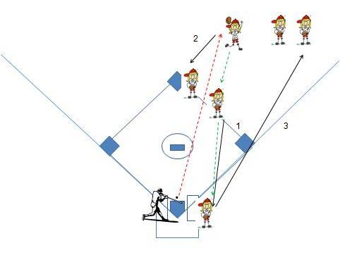

Position players in two lines in the outfield. One player is in the deep outfield, the other in a position to be the relay. Finally, have a player catching for you. Hit the ball to the deep player who catches the ball (after positioning her feet properly) and relays the ball to the cut-off player (who catches and throws the ball properly positioning her feet) who then throws the ball to the person catching. Each player takes three hits. The deep player moves to the cut off line, the cut off player comes in and catches, and the catcher goes out to the deep line. Repeat to give every player an opportunity to be both the deep fielder and the cut-off.
Worked on: Finding a pop up, properly calling for the ball, team work, proper foot work in handling and throwing the ball.

Name of Drill: Fly Ball Drill
Who: Primarily Outfielders, but good for entire team
Duration: 20 minutes
Explanation: The object of this drill is to practice calling for the ball, catching fly balls, and backing up the play.
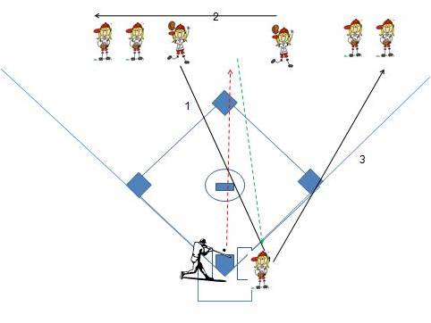

Position players in two lines in the outfield about thirty feet apart. Hit the ball between the two players. One player should call and catch the ball while the other player backs the play up. Player in the right line moves to the left line, the left line player comes in and catches and the catcher goes to the right line.
Worked on: Finding a pop up, properly calling for the ball, team work, proper foot work in handling and throwing the ball.

Name of Drill: Trash Can Throw
Who: Entire Team
Duration: 20 minutes
Explanation: The object of this drill is to practice accurate throws from shallow outfield to home plate.
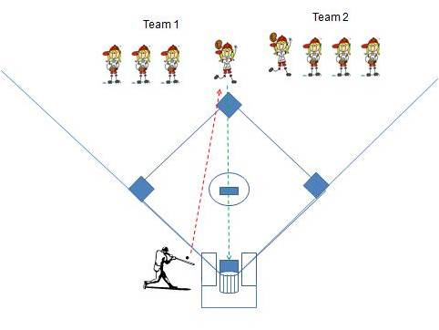

Have all of the players line up behind second base in the shallow outfield. Have one player step up to field the ball. Hit a ground ball up the middle. The player fields the ball and throws the ball into the trash can lying on its side on home plate (open end towards second base). You can also teach the players how to "crow hop" with this drill by placing an empty bat bag in front of the player fielding. They are required to field the ball then crow hop over the empty bat bag while throwing the ball to home plate. The crow hop technique improves the strength of the throw.
Worked on: Fielding ground balls, accuracy of the throw, proper foot work in handling and throwing the ball.

Fastpitch Drills:
Base Running and Stealing Bases

It is often said that you can't teach speed, but by utilizing these fastpitch drills and tips, your team will learn proper base running and base stealing techniques to make your team seem even faster.
Some coaches believe that teaching base running should focus on the faster runners of the team. That is short sighted because even the slowest runner on the team should know proper running techniques to shave off whatever time possible. Make these fastpitch drills and tips a team event.
Running to First Base

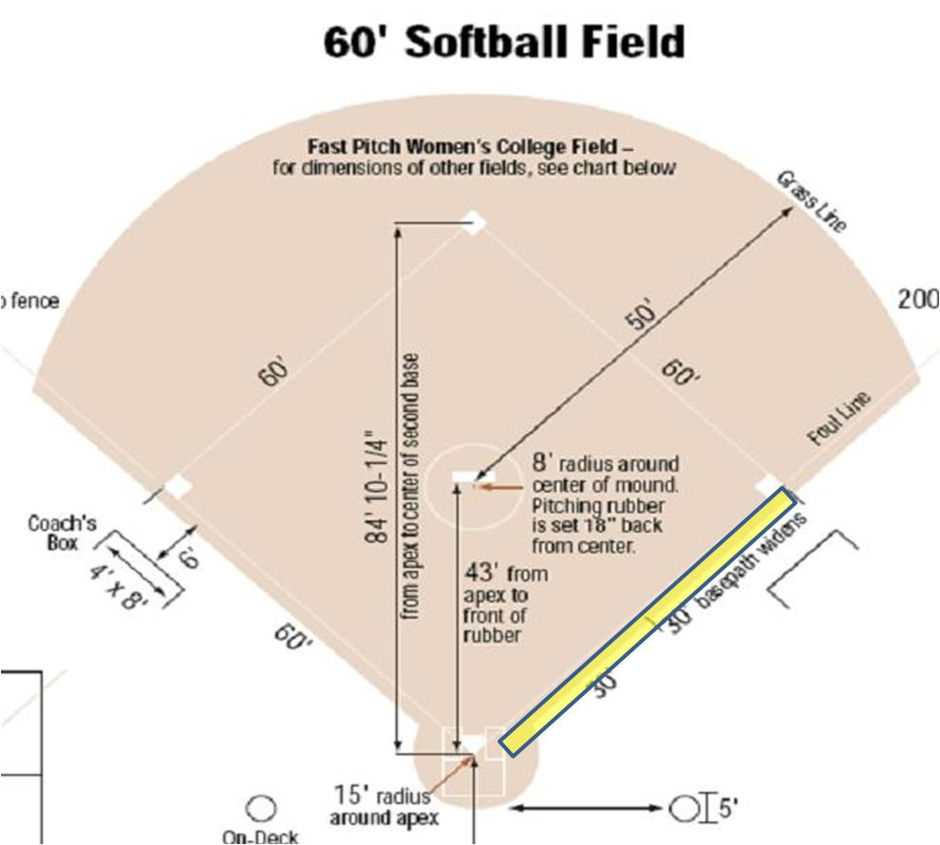

Refer to the diagram above. When teaching your players to run to first, it is important that they know to run in foul territory (highlighted in yellow). The reason for this is that if the batter lays down a bunt (or swinging bunt) and the catcher/fielder hits the runner in the back while the batter is running in fair territory, the umpire will call the hitter out for interference.
Another thing unique about first base is it is the only base where the runner can run through (overrun) the bag and safely come back to the base, as long as the batter made no attempt towards second (in other words, ran into foul territory versus making a motion towards second base.
Fastpitch Drills
Have your players form a line. The first player steps up to home plate with her bat. The coach "pitches" the ball. The batter swings the bat and runs to first base, on the foul side of the foul line and through the first base bag. Repeat this fastpitch drill for all of the players. Time your players. In subsequent practices, challenge them to beat their previous time.

Running the Bases

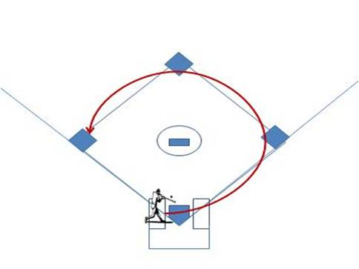

Refer to the diagram above. When looking to travel more than one base at a time, the base runner should look to touch the lower inside corner of the bag with her right foot, as illustrated by the red line in the diagram. If she is running from home to first to second or any other multiple base run, she should swing a little wide prior to the approach of the intermediary base so as to hit the inside corner and travel directly to the next base. This is illustrated by the red line in the diagram.

Fastpitch Drills
Have your players form a line. The first player steps up to home plate with her bat. The coach "pitches" the ball. The batter swings the bat and runs to first base, on the foul side of the foul line and this time runs on to second base. Make sure they make the proper approach to the bag (rounding as they come to first, hitting the inside of the bag). Repeat for all of the players. Time your players. Now, to add a little bit of change, have a third a coach stand at third as the third base coach. The third base coach will indicate whether they should slide into second or continue to third (and even home). It is important to teach your players to "pick up" or look at the third base coach half way between first and second. Again, monitor that they are approaching each base as per the diagram and also hitting the inside of the bag. In subsequent practices, challenge them to beat their previous time. This also serves as good conditioning.

Getting and Timing a Lead Off of the Base
Unlike baseball, you cannot leave the base until the ball leaves the pitcher’s hand. If you leave early, the umpire will call you out. Therefore, to get a good jump, whether to steal a base or just to get a good lead once the ball is released, it is important to employ a technique to help your runners synchronize with the release of the ball. One such technique is illustrated in the picture above. Note that the runner's arms are back and over her head. Note, also, that the runner has only her front foot on the bag. This will serve as a push off mechanism much like blocks do in a 100 meter run. As the pitcher begins her motion, the runner rocks back and moves her arms backwards. As the pitcher moves from the top of her windmill and starts moving her drive foot forward, the runner swings her arms in unison forward with the motion of the pitcher and starts to move her rear foot forward. In theory, as the runner's arms are in a forward position, helping her catapult herself off of the bag, this should be at exactly the same point that the pitcher is releasing the ball (remember, the runner's front foot is still has contact with the bag and the umpire cannot call her out for leaving the base early). This will result in a strong forward motion by the runner in unison with the pitcher's release and provide her the best opportunity to steal the base.
Fastpitch Drills
This drill is done in conjunction with your pitchers throwing off of the mound for their daily practice session. Line up half of your field players at first and the other half at second. Include the pitchers not currently throwing. Have a base runner stand at first and second, and as the pitcher goes through her motion, have the base runners go through their motion and steal the next base sliding in that base. The runner who ran to second now gets in the second base line and the runner who stole third now gets in the first base line. Repeat this exercise multiple times for each player. Time the players so that they know what they need to beat in subsequent practices.

Softball Hitting Drills:
Keep It Simple
This page and the related pages are all about providing you with a list of softball hitting drills to help your team enhance the abilities at the plate. It will also get into one of the hitting techniques that has been found to be very effective. But try to keep it simple. And, also remember the old adage: "If it ain't broke, don't fix it". That goes especially for hitting. If you have a player hitting the cover off of the ball, no matter how much you hate her swing, leave it alone!! It works for her.
Yogi Berra once said:
Think! How ... are you gonna think and hit at the same time?
Exactly! The last thing you want your player doing at the plate is thinking too much about her swing. The swing should be automatic and natural because it's been repeated again and again with "perfect practice". Using some combination of the softball hitting drills referred to should make that swing come more natural.

Each of the sections will also discuss bunting and slapping. The short game or the ability to bunt is extremely important in the game of fastpitch softball. If you run into a very strong pitcher who has your hitters totally flummoxed or over-powered, sometimes the only way to beat that pitcher is by deploying a bunting game.

Practice and Game Day Warm up Drills: Bunting
Putting in a couple of warm up drills as part of your pre-game ritual will pay dividends when you actually need one of your players to drop the perfect bunt in the perfect location during the game.
Provided will be a few ways to teach bunting to those who have never bunted before. One of my favorite hitting tools is the broom handle. Yes, I said the broom handle. I made a broom handle a required piece of equipment for every player on my team. As a matter of fact, as soon as a new player got the welcome letter, I handed them a broom handle. You will be amazed how many different drills you can do with a broom handle. And how much good it will do to assist in perfecting your player's swing.
In order to ensure that your players are confident that not only can they get the bunt down but also place it where you want them to put it will require working on drills that emphasize these factors. To keep things consistent with your regular practice drills for bunting, use a variation of those drills that account for the contained space, but work on hand and eye focus. Below are some examples.
Name of Warm up Drill: Broomstick & Wiffle Balls
Who: Entire Team
Duration: Rotation through the entire team
Explanation: The player uses her broom stick as her bat. A coach throws the regular size wiffle ball relatively hard (overhand), which the player must bunt either down the "first base line" (to her right) or down the "third base line" to her left. Note that this drill will likely be in the outfield or on a practice field, so the baselines are imaginary). The coach should focus on making sure that the player is properly executing her bunting technique (turned at the waste, knees bent, top of the bat even with the top of the shoulders and the pivot hand properly holding the bat with the steering hand in position).
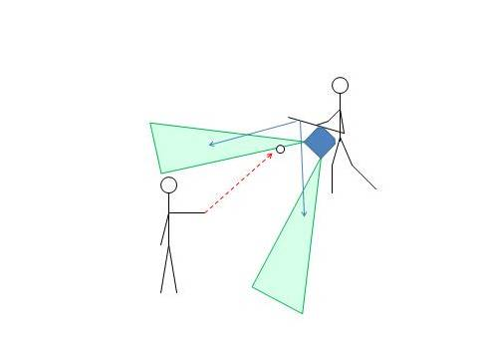
Worked on: Perfecting her bunting technique, bunting to a location, not bunting back to the pitcher. Note that there are also psychological benefits. If the player can bunt a regular size wiffle ball (slightly smaller than a softball) with her broomstick (much thinner than her bat) there is no reason she will not be able to bunt a softball with a softball bat.

Name of Warm up Drill: Broomstick & golf ball size wiffle balls
Who: Entire Team
Duration: Rotation through the entire team
Explanation: This drill is essentially the same as the previous drill, except now the golf ball size wiffle balls are used. The player uses her broom stick as her bat. A coach throws the golf ball size wiffle ball relatively hard (overhand), which the player must bunt either down the "first base line" (to her right) or down the "third base line" to her left. Note that this drill will likely be in the outfield or on a practice field, so the baselines are imaginary). The coach should focus on making sure that the player is properly executing her bunting technique.
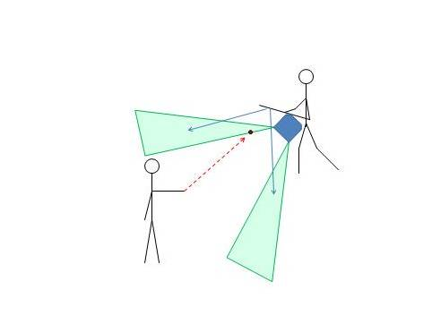
Worked on: Perfecting her bunting technique, bunting to a location, team work, not bunting back to the pitcher, quickness of reaction time. Note that this drill has even bigger psychological benefits. If the player can bunt a golf ball size wiffle ball (considerably smaller than a softball) with her broomstick (much thinner than her bat), which is being thrown at a high rate of speed, there is no reason she will not be able to bunt a softball with a softball bat.

Name of Warm up Drill: Quad-Group Bunting
Who: Entire Team
Duration: Rotation through the entire team
Explanation: The team is broken down into groups of four. As with the above drill, the object is for the batter to bunt the ball into the safety area. Needed for this drill are the golf ball size wiffle balls and the batter's broom stick. This time, however, there are three pitchers. One pitcher is located on the first baseline, the other on the third base line and the third pitcher behind the batter. Give each pitcher half of the gold ball size wiffle balls. The pitchers take turns throwing the ball. As soon as the first pitched ball is bunted the second pitcher throws her ball. As soon as the second pitched ball is bunted, the third pitcher throws her ball (and so on). The object is to increase reaction time of the batter, by rotating to bunt each ball while maintaining her proper bunting form as she spins into the proper location to bunt the ball. Once all of the balls are played, rotate through the four-some.
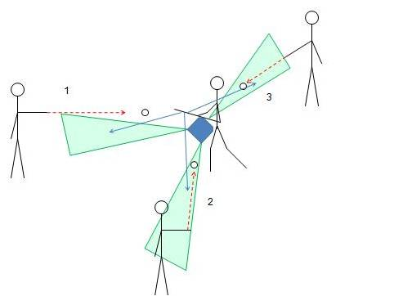
Worked on: Perfecting her bunting technique, bunting to a location, team work, not bunting back to the pitcher, quickness of reaction time.

Fastpitch Softball Hitting Drills:
Game Day and Practice Drills
Once you have the hitting mechanics in place, fastpitch softball hitting drills will make those mechanics automatic. If the team is following direction and using the broom stick, these drills will further enhance bat speed and hand and eye coordination.
Below are a few fastpitch softball hitting drills that can be used during your practice or as a pre-game warm-up. They do not take up a lot of space, but are very effective. For hitting practice in general, there is nothing like live pitching. Make a game out of it, by splitting the team up into three teams, where the infield, outfield and hitters are three different teams. This gives not only your pitcher some live situations, but also your hitters and fielders. There is nothing like a little inter-squad competition to get practice focused. This drill is usually best at the end of the practice.
Now for a few fastpitch softball hitting drills for those tight spaces.
Name of Drill: Soft Toss
Who: Entire Team
Duration: Rotation through the team
Explanation: This is the baseline drill, usually in two person groups. You will need a bucket of softballs, the hitting net, and the player's bat. As one works on her swing, hitting the ball into the net, her teammate under-hands the ball into the hitting zone. After completing the bucket, the players switch places. This is a basic drill that many team use.
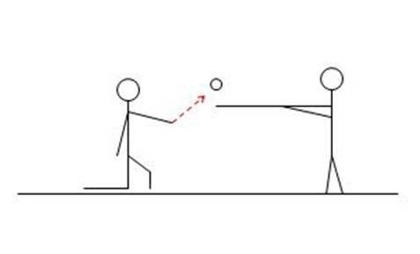
Worked on: Perfecting her swing on pitches in various parts of the strike zone, repetition of the swing (performed correctly), warm up for the game.
.

Name of Drill:Drop Ball
Who:Entire Team
Duration: Rotation through the team
Explanation: The team can be broken down into pairs. You will need a bucket of softballs, the hitting net, something to stand on (bleachers, ball can, step stool) and the player's bat. The object of this drill is to increase bat speed. The coach or batter's partner stands on the something to stand on, and drops the ball directly over the plate or hitting zone. As the ball is dropped, the batter must hit the ball into the net. Although this sounds like a simple task, the impact of the accelerating speed of the ball due to gravity will likely make the first time a player tries this a little difficult. Persevere, and bat speed will improve.
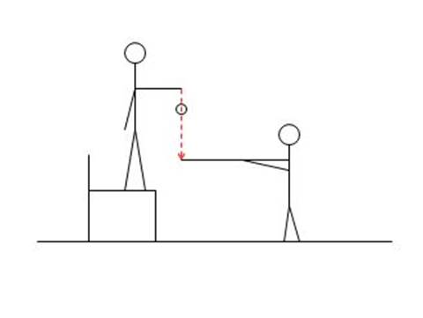
Worked on: Quick hands to the ball and improved bat speed.

Name of Drill:From Behind Toss
Who:Entire Team
Duration: Rotation through the team
Explanation: The team can be broken down into pairs. You will need a bucket of softballs, the hitting net, and the player's bat. The object of this fastpitch softball hitting drill is to increase reaction time to the pitched ball. The batter's partner kneels behind the hitter and tosses the ball through the strike zone towards the hitting net. The batter can not look back, but as the ball crosses the hitting area, must see the ball, react and hit the ball.
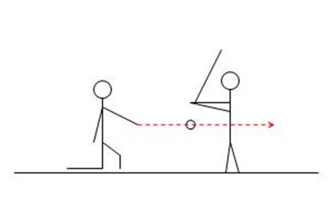
Worked on: Bat speed, peripheral vision, quick hands to the ball.

Rotational Hitting

Master these steps and you are on your way to achieving your goal of being a hitter that can go as far as your dreams, desires, and hard work can take you.

JUMP INTO THE BOX
The stance is similar to when you land from a jump - knees bent - feet slightly wider than your shoulders - on balance - bend slightly forward from the waist.

GET ON THE PLANE
Since we want to hit the ball over the infielder's heads, into the gaps of the outfield, we need to bend into an angle that will put you on a "plane" that lines up with where you want to hit it.

VaVOOM
The start of an explosive and powerful swing. Va - involves a pre-motion for the lead leg, such as a slight step, or a raising of the leg, or even just a raising on to the big toe, followed by VOOM - an explosive dropping (planting) of the heel, which leads immediately to . . .

ELVIS PELVIS
The powerful force of the rotating hips starts with the heel drop (VOOM) which pulls the rear hip (pelvis) toward the front side in a move Elvis would've been proud of. From the axis of your bend (or dip) this move goes into spinning the . . .

WEED WHACKER
The key to powerful hitting is spinning the middle (torso) of your body as quickly as possible so that by keeping the bat connected to the rotational force, it swings around much like the nylon cord of a weed whacker. The bat will be spinning perpendicular to the axis you set when you got on the plane.

PALM UP - PALM DOWN
When the bat comes around the rotation, on plane with the pitch, contact is made most strongly with the bottom (or pull hand) being wrapped around the bat with the palm facing in a downward direction and the top hand's palm (or guide hand) facing upwards (in relation to the body's angle, not to the ground).

